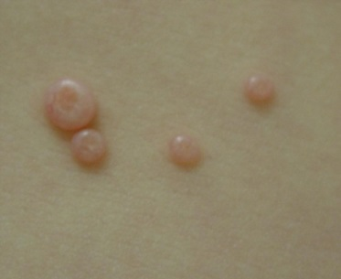
Molluscum Contagiosum

What is molluscum?
- Common skin infection in children
- Produces harmless, noncancerous growths in the skin’s top layers
- Most common in children ages one to ten years
- Spread by direct contact with the skin of an infection person
- Can be spread by sharing towels, clothing, toys, etc.
http://www.cdc.gov/ncidod/dvrd/molluscum/image_less_severe_molluscum_closeup_lg.htm
- Bumps are painless and may last for several months to a few years!

Symptoms:
- Small number (usually between 2-20) of raised, dome-shaped bumps on the skin
- Bumps are very small and flesh-colored
- Rash is most often found on the face, trunk, and extremities
- May develops anywhere except palms of the hands and soles of the feet!
- Rash is usually painless but may be itchy or sore

When to call the doctor:
- If you suspect your child has molluscum or if you are unsure

Treatment:
- Molluscum usually goes away on its own without treatment
- Bumps can be removed in-office if you or your child desires
  - Scraping, peeling or freezing techniques – may be painful

Prevention:
- Avoid skin-to-skin contact with another child or adult with molluscum
- If you or your child has molluscum, keep areas covered (with clothing or bandage) if infected area may come in direct contact with others (always remove bandage before bed)

Home Remedies:
- Apple Cider Vinegar
  - Soak cotton ball with apple cider vinegar
  - Tape cotton ball to affected area with medical tape
  - Leave treatment on overnight, reapply as needed
  - Bumps will turn white and then fall off or disappear within several days
- Duct tap
  - Apply small piece of duct tape on the bump overnight and remove it in the morning
  - Use nightly until bump is gone

