Ear Infections & Antibiotics

Middle ear infections (otitis media) are very common during childhood. A child’s ear is more likely to develop an infection because the anatomy of the ear is smaller, making it easier for germs to reach the middle ear. The peak incidence of ear infections is between six months and two years of age. Abington Pediatrics believes in educating you, the parent, on the different illnesses in childhood so that you can provide the best possible care to your child.

Middle ear infections are the most common infection treated by antibiotics. However, new research has shown that antibiotics may not be necessary in treating a middle ear infection, as many resolve on their own.

The American Academy of Pediatrics is concerned with the overuse of antibiotics when treating middle ear infections based on the following:
- 80% of ear infections resolve on their own without antibiotics
- The pain caused by ear infections can be well controlled with acetaminophen (Tylenol) or ibuprofen (Motrin) until the infection resolves
- It is extremely rare for recurrent ear infections to cause permanent hearing loss
- Persistent fluid in the middle ear may not affect language development long term
- Overuse of antibiotics can lead to the bacteria developing a resistance to the drugs

Common symptoms of middle ear infections (depending on the age of the child):
- Ear pain
- Fever
- More crying than usual
- More pain when laying down flat
- Trouble sleeping or hearing
- Pulling/tugging on the ears or sticking finger in the ears
- Fluid from the ears

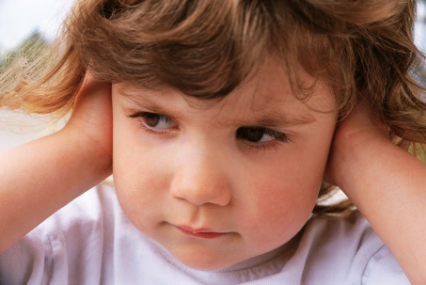

If you feel that your child may have a middle ear infection and is afebrile (fever-free), please try the following at home:
- Give Tylenol or Motrin for pain control
- Apply cool compress to the outside of the ear if possible

Please call the office for an appointment if:
- Child is under 6 months of age
- Pain persists for more than 48 hours
- Fever develops
- Your child is not acting well
- Outside of ear is red, painful and/or swollen
- Fluid from the ears

