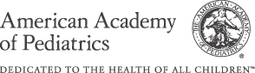

Abington Pediatrics Infant Feeding Guideline
Newborn to Four Months of Age

Newborn: 1-2 oz of formula every 2-3 hours or breast feeding (BF) ad lib

One month: 3-4 oz of formula every 3-4 hours or BF ad lib

Two & Three months: 4-6 oz of formula every 3-4 hours or BF ad lib

Four Months: 6-8 oz of formula every 4 hours of BF ad lib

